CHAPTER FOUR

# RESULTS

## Summary of species caught.

Species belonging to 10 families were caught during the study. Since the family Anguillidae family was the target interest of study, 9 different families were caught as by-catch. Tank gobby (*Glossogobius giuris* Hamilton, 1822), dominated the catch with 947 individuals and had a mean total length 14 ±10SD cm with a mean weight of 23 grams. Sabaki tilapia (*Oreochromis spirulus spirulus* Gunther, 1894) had an abundance of 118 individuals with an average weight of 26 grams with a standard length and total length of 12 cm and 15 cm respectively. Anguillidae individuals from *A. bengalensis* species. *Anguilla bengalensis* had an average total length of 5.5 cm weighing 5 grams. Mozambique tilapia (*Oreochromis mossambicus* Peters,1852) had 47 individuals, then the snake eel had 45 individuals. Snake eels (*Pisonodophis boro* Hamilton 1822) were the longest, having a total length of 108 cm and weighing 71 grams. Table 1 illustrates the summary results of the caught species. The target species belonging to *Anguillidae* family were *A. bengalensis* which were most abundant with 50 individuals, followed *A. mossambica* with 23 individuals and *A.* *marmorata* with 2 individuals.

Table 1: Summary of species composition caught in the study area.

| Species | Morphometric Measurements | | | | |
| --- | --- | --- | --- | --- | --- |
| Abundance | Total length (cm) | Standard length (cm) | Depth (cm) | Weight (g) |
| ***Anguillidae*** | | | | | |
| *Anguilla mossambica* | 23.0 | 6.519048 | NaN | NaN | 5.250000 |
| *Anguilla bengalensis* | 51.0 | 5.551020 | NaN | NaN | 5.150000 |
| *Anguilla marmorata* | 2.0 | 5.000000 | NaN | NaN | 5.100000 |
| ***Gobiidae*** | | | | | |
| *Glossogobius giuris* | 946.9 | 14.549023 | 10.006391 | 5.347368 | 23.262911 |
| *Stenogobius kenyae* | 25.0 | 69.968000 | 57.040000 | 12.376000 | 17.320000 |
| ***Portunidae*** | | | | | |
| *Scylla serrata* | 41.0 | 10.500000 | 5.100000 | 9.000000 | 21.297297 |
| ***Penaeidae*** | | | | | |
| *Penaeus indicus* | 5.0 | NaN | NaN | NaN | 529.285714 |
| *Ophichthidae* | | | | | |
| *Pisonodophis boro* | 45.0 | 108.695455 | NaN | 8.716667 | 71.351111 |
| ***Sciaenidae*** | | | | | |
| *Otolithes ruber* | 14.0 | 20.215385 | 16.761538 | 7.950000 | 21.692308 |
| ***Mugilidae*** | | | | | |
| *Planiliza alata* | 24.0 | 4.263158 | 4.968421 | NaN | 2.666667 |
| ***Bagridae*** | | | | | |
| *Bagrus docmak* | 1.0 | 16.600000 | 13.000000 | NaN | 38.000000 |
| *Bagrus docmak* | 35.0 | 39.442857 | 32.405714 | 7.546875 | 78.371429 |
| ***Cichlidae*** | | | | | |
| *Oreochromis spirulus spirulus* | 118.0 | 15.355556 | 12.486250 | 4.787500 | 26.644737 |
| *Oreochromis mossambicus* | 47.0 | 16.326471 | 11.791176 | 4.615152 | 15.882353 |
| ***Cyprinidae*** | | | | | |
| *Barbus oxyrhynchus* | 1.0 | 124.000000 | 97.000000 | 32.000000 | 19.000000 |

## Life stage and species occurring within the Sabaki Estuary

A total of 76 juvenile anguillid eels were collected. The individual life stages observed to occur in the Sabaki Estuary were, glass eels, which appeared transparent in colour (Figure 6) and elvers which appeared pigmented (Figure 7). Glass eels were more abundant at 87% (n = 66) while elvers were less abundant at 13% (n = 10), Table 2.

Table 2: Results showing life stages of juvenile anguillid eels captured in the Sabaki Estuary

| Anguillid life stage | Frequency (%) |
| --- | --- |
| Elver | 10 (13%) |
| Glass eel | 66 (87%) |

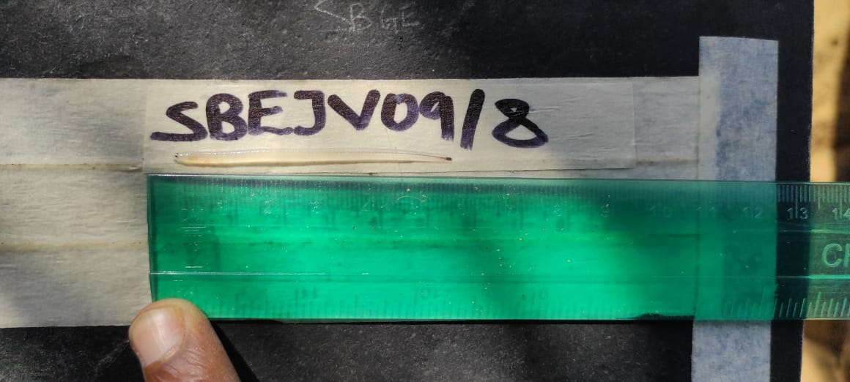

Figure 6: A photograph displaying the transparent colouration of a glass eel captured in the Sabaki Estuary, previously preserved in ethanol (Photo by Gitonga, 2021)

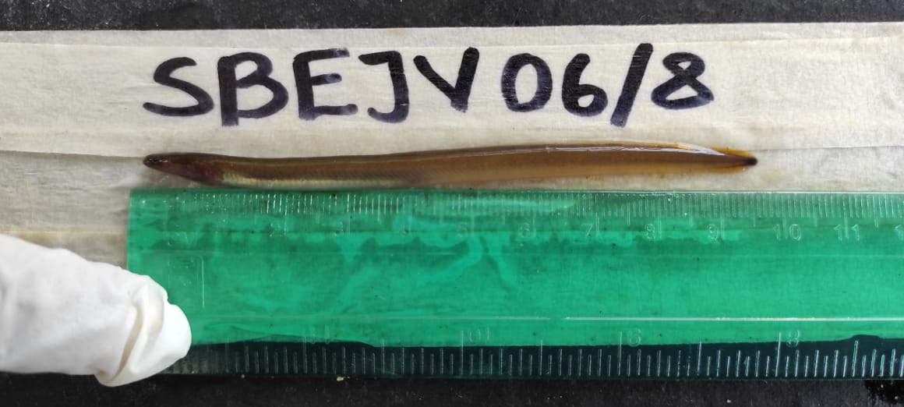

Figure 7: A photograph displaying an elver with pigmentation captured in Sabaki Estuary (Photo by Gitonga, 2021)

Among the juvenile anguillid eels captured, *A. bengalensis* (Figure 8)was the most abundant (n = 50). This was followed by *A. mossambica* (Figure 9)*,* with 23 individuals while only 3 individuals of *A. marmorata* (Figure 10)*,* were captured as presented in Table 3.

Table 3: Species of anguillid eels caught in the Sabaki Estuary

| Species | Local name | Number of individuals |
| --- | --- | --- |
| *A. bengalensis* | Mkunga | 50 |
| *A. mossambica* | Mkunga | 23 |
| *A. marmorata* | Mkunga | 3 |

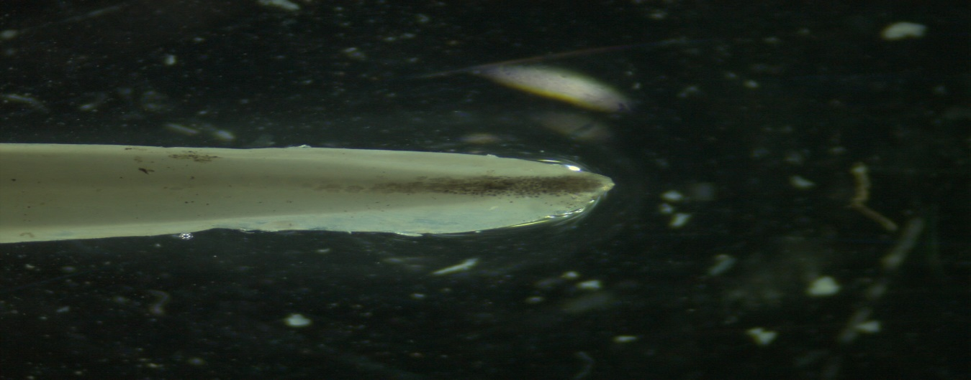

**SBEJV22/8 (*Anguilla bengalensis*)**

Figure 8: A photograph showing tail pigmentation of A. bengalensis glass eel taken by Stemi 305, Carl Zeis microscope GmbH, Germany using ZEN imaging software at x 2 magnification.

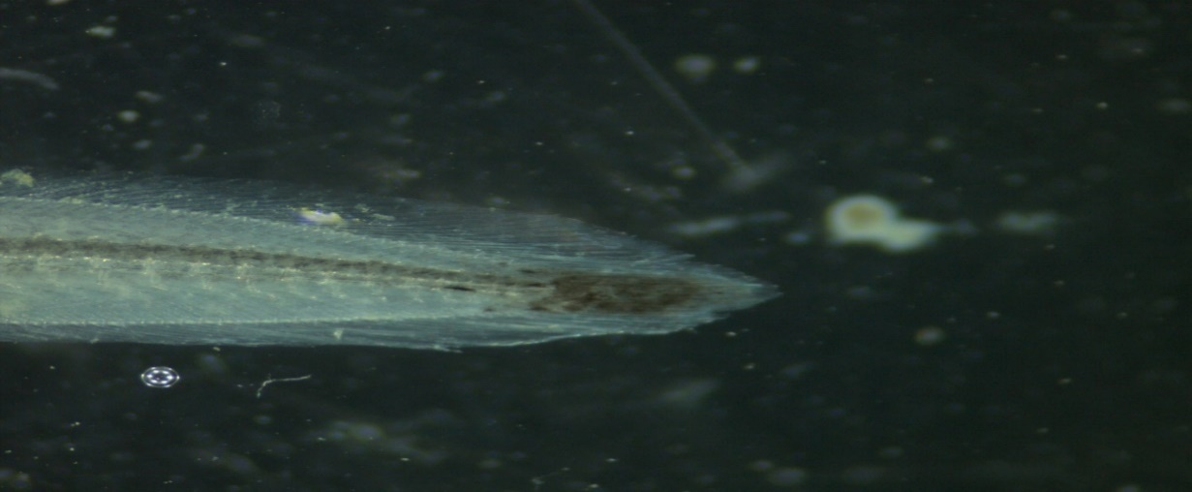

**SBEJV05/8 (*Anguilla mossambica*)**

Figure 9: A photograph showing tail pigmentation of A. mossambica glass eel taken by Stemi 305, Carl Zeis microscope GmbH, Germany using ZEN imaging software at x 2 magnification.

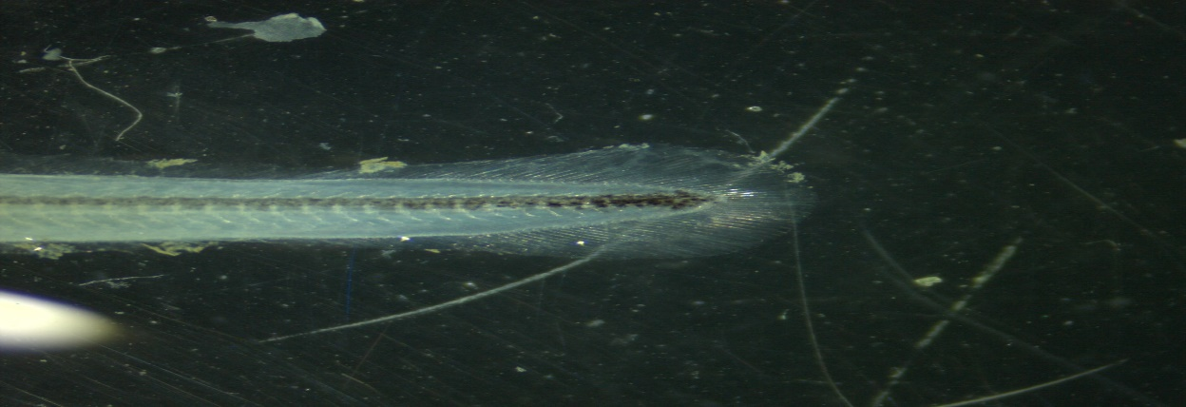

**SBEJV04/8 (*Anguilla marmorata*)**

Figure 10: A photograph showing tail pigmentation of A. marmorata glass eel taken by Stemi 305, Carl Zeis microscope GmbH, Germany using ZEN imaging software at x 2 magnification.

Most of the juvenile anguillid eels caught were glass eels (Table 4). Only *A. mossambica* and *A. bengalensis* species had elvers. *Anguilla bengalensis* were the most abundant with 52 individuals, with 50 being glass eels and 2 elvers. This was followed by *A. mossambica* with 22 individuals where, 15 were glass eels and 8 were elvers. Only two *A. marmorata* were caught during this study.

Table 4: Life Stages of juvenile anguillid species captured in the Sabaki Estuary

Table 4: Number of glass eels and elvers of the three species of anguilid eels sampled in Sabaki estuary during the study.

|  |  |  |  |
| --- | --- | --- | --- |
| Species | Life stage | | Total |
| Glass Eel | Elver |
| *A. bengalensis* | 50 | 2 | 52 |
| *A. mossambica* | 14 | 8 | 22 |
| *A. marmorata* | 2 | 0 | 2 |
| Total | 66 | 10 | 76 |

## Juvenile anguillid eels morphometrics

Morphometric results showed that, *A. mossambica* was the largest anguillid with 63 ± 18 SD mm followed by *A. bengalensis* at 54 ± 5 SD mm while *A. marmorata* smallest of the three anguillids with 51 ± 4SD mm (Table 5). One-way analysis of variance (ANOVA) showed that the mean differences in total length among the three anguillid species were not statistically significant (ANOVA, p = 0.1). Fin morphometrics showed that, *A. mossambica* had the largest DF to AF length with 249 ± 282SD mm followed by *A. bengalensis* with 124 ± 43SD mm while *A. marmorata* had the shortest DF to AF length with 112 ± 25SD mm. The mean differences in DF to AF lengths were statistically significant among the three anguillid species as attested by the ANOVA results (ANOVA, p = 0.008). Results of FDI calculating the length between dorsal and dorsal fin relative to the total length (LT) did not conform to Ege, (1939) taxonomic key. FDI for all for all 76 specimens were < 1% (Appendix 4).

Both eye and fin morphometric measurements showed a similar trend with *A. mossambica* having the largest morphometric measurements followed by *A. marmorata* and trailed by *A. bengalensis* though they were not statistically significant.

Table 5: Morphometrics of juvenile anguillids occurring in the Sabaki Estuary

| **Morphometrics (mm)** | **Anguilla bengalensis** | **Anguilla marmorata** | **Anguilla mossambica** | **P-VALUE (Anova)** |
| --- | --- | --- | --- | --- |
| Total length | 54 ± 5 | 51 ± 4 | 63 ± 18 | 0.10 |
| DF TO AF | 124 ± 43 | 112 ± 25 | 249 ± 282 | 0.015 |
| DA | 107 ± 45 | 91 ± 24 | 215 ± 270 | 0.026 |
| DG | 17.9 ± 6.3 | 19.3 ± 1.5 | 19.7 ± 6.3 | 0.2 |
| LH | 63 ± 8 | 65 ± 6 | 82 ± 73 | 0.5 |
| LV | 60 ± 10 | 61 ± 5 | 80 ± 75 | 0.9 |
| RH | 60 ± 9 | 60 ± 5 | 80 ± 73 | 0.5 |
| RV | 60 ± 9 | 62 ± 10 | 82 ± 75 | 0.4 |

Seasonal occurrence of anguillids

Most anguillids were caught during the wet season (53) against 23 caught in the dry season. The Anguilla marmorata were only caught during the wet season. There was an association between anguillid species occurrence and seasons (p = 0.032).

| season | Anguilla bengalensis | Anguilla marmorata | Anguilla mossambica | Total | p-value |
| --- | --- | --- | --- | --- | --- |
| Dry | 20 (87%) | 0 (0%) | 3 (13%) | 23 (100%) | 0.032 |
| Wet | 30 (57%) | 4 (7.5%) | 19 (36%) | 53 (100%) |  |
| Total | 50 (66%) | 4 (5.3%) | 22 (29%) | 76 (100%) |  |

Seasonal occurrence of anguillids’ life stages

| season | Anguilla bengalensis | | Anguilla mossambica | | Anguilla Marmorata | | Total | |
| --- | --- | --- | --- | --- | --- | --- | --- | --- |
|  | Elvers | Glass eels | Elvers | Glass eels | Elvers | Glass eels | Elvers | Glass eels |
| Wet | 2 (20%) | 28 (65%) | 8 (80%) | 11 (26%) | 0 | 4 (9.3%) | 10 (100%) | 42 (100%) |
| Dry | 0 | 20 (87%) | 0 | 3 (13%) | 0 | 0 | 0 (100) | 23 (100%) |
| Total | 2 (20%) | 48 (73%) | 8 (80%) | 14 (21%) | 0 | 4 (6.1%) | 10 (100%) | 65 (100%) |

Occurrence of anguillids across the phases of the moon

| Phases of Moon | Anguilla bengalensis | Anguilla marmorata | Anguilla mossambica | Total | p-value |
| --- | --- | --- | --- | --- | --- |
| First Quarter | 8 (57%) | 2 (14%) | 4 (29%) | 14 (100%) | 0.2 |
| Full moon | 10 (100%) | 0 (0%) | 0 (0%) | 10 (100%) |  |
| Last Quarter | 8 (67%) | 0 (0%) | 4 (33%) | 12 (100%) |  |
| Wanning Gibbous | 18 (64%) | 1 (3.6%) | 9 (32%) | 28 (100%) |  |
| Waxing Crescent | 6 (50%) | 1 (8.3%) | 5 (42%) | 12 (100%) |  |
| Total | 50 (66%) | 4 (5.3%) | 22 (29%) | 76 (100%) |  |

Occurrence of anguillid’s life stages across the phases of the moon

| Phases of Moon | Anguilla bengalensis | | Anguilla marmorata | | Anguilla mossambica | | Total | |
| --- | --- | --- | --- | --- | --- | --- | --- | --- |
|  | Glass eels | Elvers | Glass eels | Elvers | Glass eels | Elvers | Glass eels | Elvers |
| First Quarter | 8 (57%) | 0 | 2 (14%) | 0 | 4 (29%) | 0 | 14 (100%) | 0 |
| Full moon | 10 (100%) | 0 | 0 (0%) | 0 | 0 (0%) | 0 | 10 (100%) | 0 |
| Last Quarter | 8 (89%) | 0 (0%) | 0 (0%) | 0 | 1 (11%) | 3 (100%) | 9 (100%) | 3 (100%) |
| Wanning Gibbous | 16 (73%) | 2 (33%) | 1 (4.5%) | 0 | 5 (23%) | 4 (67%) | 22 (100%) | 6 (100%) |
| Waxing Crescent | 6 (55%) | 0 (0%) | 1 (9.1%) | 0 | 4 (36%) | 1 (100%) | 11 (100%) | 1 (100%) |
| Total | 48 (73%) | 2 (20%) | 4 (6.1%) | 0 | 14 (21%) | 8 (80%) | 66 (100%) | 10 (100%) |

Temporal occurrence of Anguillids

| Sampling Month | Anguilla bengalensis | Anguilla marmorata | Anguilla mossambica | Total | p-value |
| --- | --- | --- | --- | --- | --- |
| July | 1 (50%) | 0 (0%) | 1 (50%) | 2 (100%) | 0.2 |
| August | 29 (57%) | 4 (7.8%) | 18 (35%) | 51 (100%) |  |
| September | 1 (50%) | 0 (0%) | 1 (50%) | 2 (100%) |  |
| October | 10 (100%) | 0 (0%) | 0 (0%) | 10 (100%) |  |
| November | 9 (82%) | 0 (0%) | 2 (18%) | 11 (100%) |  |
| Total | 50 (66%) | 4 (5.3%) | 22 (29%) | 76 (100%) |  |

Temporal occurrence of anguillid’s life stages

| Sampling Month | Anguilla bengalensis | | Anguilla marmorata | | Anguilla mossambica | | Total | |
| --- | --- | --- | --- | --- | --- | --- | --- | --- |
|  | Glass eels | Elvers | Glass eels | Elvers | Glass eels | Elvers | Glass eels | Elvers |
| July | 1 (50%) | 0 (0%) | 0 (0%) | 0 (0%) | 1 (50%) | 0 (0%) | 2 (100%) | 0 (0%) |
| August | 27 (66%) | 2 (20%) | 4 (9.8%) | 0 (0%) | 10 (24%) | 8 (80%) | 41 (100%) | 10 (100%) |
| September | 1 (50%) | 0 (0%) | 0 (0%) | 0 (0%) | 1 (50%) | 0 (0%) | 2 (100%) | 0 (0%) |
| October | 10 (100%) | 0 (0%) | 0 (0%) | 0 (0%) | 0 (0%) | 0 (0%) | 10 (100%) | 0 (0%) |
| November | 9 (82%) | 0 (0%) | 0 (0%) | 0 (0%) | 2 (18%) | 0 (0%) | 11 (100%) | 0 (0%) |
| Total | 48 (73%) | 2 (20%) | 4 (6.1%) | 0 (0%) | 14 (21%) | 8 (80%) | 66 (100%) | 10 (100%) |